What is a Serial used for?

Does serial always need to be PK

Why do we need a FK Constraint?

Go to Northwind and create an ER Diagram in PGAdmin tool

How is a many to many relation managed in a RDBMS

What is BPChar

Check the hard disk.. how are the data files stored

What is pg_catalog and information_schema

Explain how date is stored

Drop cascade

Delete with returning.. does it work?

What is double quotes

Can you create multiple UK on the same set of columns?

Hidden columns - What are they used for?

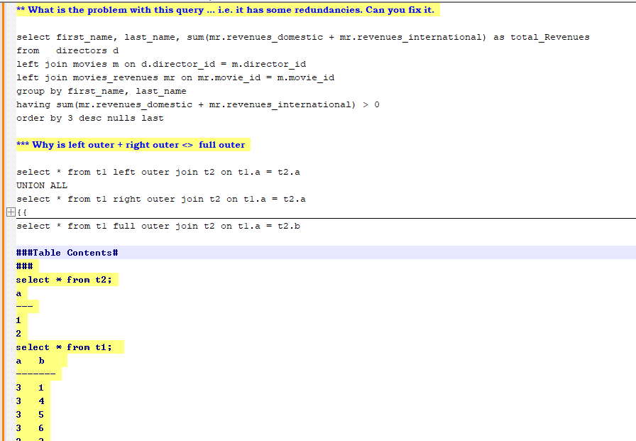

### Performance Tuning # ##Set this up and we will look at plans

# Setup #

drop table t1;

create table t1(x int, y int);

insert into t1 values(1,NULL);

insert into t1 values(1,2);

insert into t1 values(2,2);

insert into t1 values(3,2);

insert into t1 values(4,1);

insert into t1 select * from t1;

insert into t1 select * from t1;

insert into t1 select * from t1;

insert into t1 select * from t1;

insert into t1 select * from t1;

insert into t1 select * from t1;

insert into t1 select * from t1;

insert into t1 select * from t1;

insert into t1 select * from t1;

insert into t1 select * from t1;

insert into t1 select * from t1;

insert into t1 select * from t1;

insert into t1 select * from t1;

insert into t1 select * from t1;

insert into t1 select * from t1;

insert into t1 select * from t1;

insert into t1 select * from t1;

insert into t1 select * from t1;

insert into t1 select * from t1;

alter table t1 add column a char(500);

alter table t1 add column b char(500);

alter table t1 add column c char(500);

alter table t1 add column d char(500);

alter table t1 add column e char(500);

alter table t1 add column f char(500);

alter table t1 add column g char(500);

alter table t1 add column h char(500);

alter table t1 add column i char(500);

alter table t1 add column j char(500);

alter table t1 add column k char(500);

alter table t1 add column l char(500);

update t1 set a = 'some long string that should be 500 chars',

b = 'some long string that should be 500 chars',

c = 'some long string that should be 500 chars',

d = 'some long string that should be 500 chars',

e = 'some long string that should be 500 chars',

f = 'some long string that should be 500 chars';

update t1 set g = 'some long string that should be 500 chars',

h = 'some long string that should be 500 chars',

i = 'some long string that should be 500 chars',

j = 'some long string that should be 500 chars',

k = 'some long string that should be 500 chars',

l = 'some long string that should be 500 chars';

create index idx1 on t1(x);

#### Joins

create table opening_pairs(

team_name varchar(20),

player_name varchar(20));

insert into opening_pairs values('India','Rahul'),('India','Rohit'),

'Australia','Khwaja'),('Australia','Warner'),

('South Africa','De Kock'),('South Africa','Miller');

Output Expected

|  |  |  |
| --- | --- | --- |
| India | Rohit | Rahul |
| Australia | Warner | Khwaja |
| South Africa | Miller | De Kock |

**What is wrong in this query below**

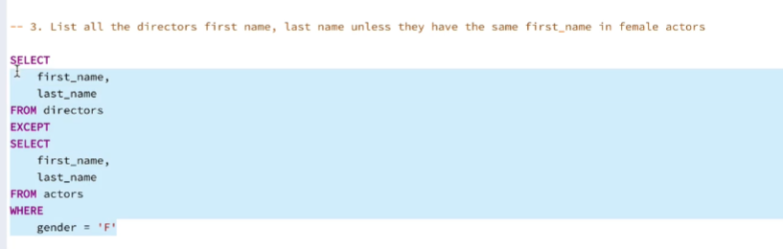

**What does the pg_dump utility do?**

**Write the query that compares 2 schemas? Let’s dissect the query.**

What is a clustered index?

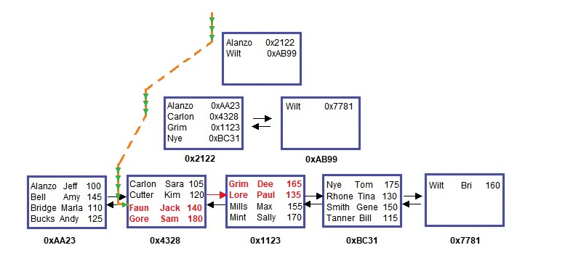

When do you create a HASH index?

What is a partial index, how is it useful?

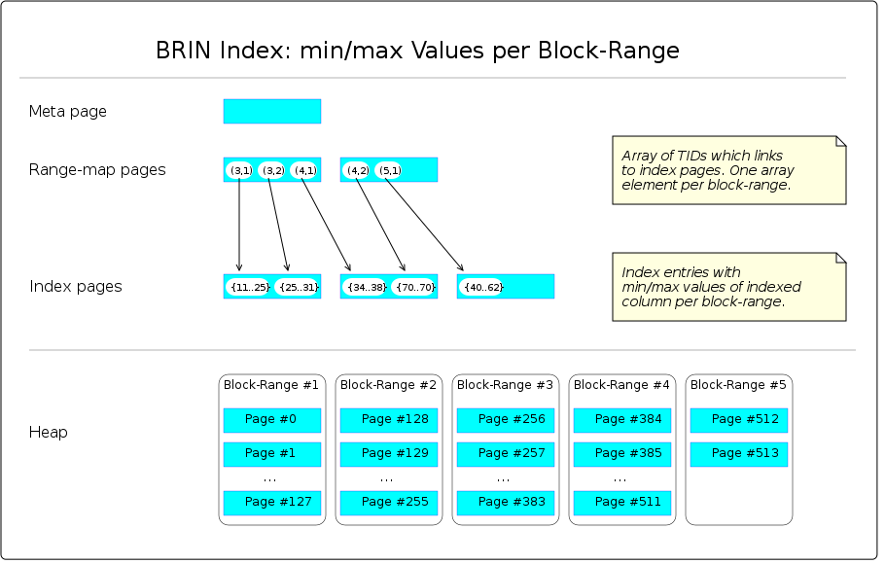

When a BRIN is created, the sequence of pages of the data file (heap) is virtually divided into slices, called *block-ranges*. E.g., if the file contains 600 pages, the first 128 belongs to block-range #1, the second 128 belongs to block-range #2, ... up to block-range #5, which contains the remaining number of pages. The default size for a block-range is 128 pages; it can be changed within the CREATE INDEX command. Next, all rows are scanned and the minimum and maximum values of the indexed column per block-range are saved. Please note that each min/max pair constitutes a numeric *value-range*.

The BRIN structure consists of those block-range numbers and their related value-ranges, e.g., block-range #1: min=11, max=25; block-range #2: min=25, max=31. Hence the name *Block Range Index*.

Ideally, the value-ranges don't overlap, but this is not necessary.

More Reading on GIN Index

<https://en.wikibooks.org/wiki/PostgreSQL/Index_GIN>

Some queries that I would need you to explain tomorrow...

select tableoid, cmax, xmax, cmin, xmin, ctid, x from t2

### PROBLEM 1

explain select * from t1 where x = 50

union

select * from t1 where x = 100

Question: How many indexes are used in the query

Why is this step happening

" Sort Key: t1.x, t1.y, t1.a, t1.b, t1.c, t1.d, t1.e, t1.f, t1.g, t1.h, t1.i, t1.j, t1.k, t1.l"

### PROBLEM 2

create table t4 (x int, y int) not null

create or replace view v_t4 as

select * from t4

select * from v_t4

alter table t4 add column z int

select * from v_t4

What happens and why

### PROBLEM 3

insert into v_t4(x) values (3) --what will happen

### PROBLEM 4

drop table t4 -- what will happen

### PROBLEM 5

LOCAL CHECK

CACADED CHECK OPTION (edited)

What is the requirement to refresh a MV concurrently

How can you generate multiple rows using a simple query

**--What will the difference between these 2 queries and the query plan**

select m.movie_name

from movies m, movies_revenues mr

where m.movie_id = mr.movie_id

and mr.revenues_domestic > mr.revenues_international

select m.movie_name

from movies m

where movie_id in (select movie_id

from movies_revenues mr

where mr.revenues_domestic > mr.revenues_international)

What is an ER Diagram - I will cover this

Cover with Check Option on a view… local and cascaded check.. what happens if the base view has check option.

Using CTE, write a query that will give customer details and number of products where the total quantity of the product ordered is greater than 100

Get all the customers where the total quantity of products is greater than average of the region that the customer belong to

The manager on employees wants to know which are the products that have been ordered but are not in stock for all employees reporting into him/her

Names of the shipping companies that do not have any orders to ship.

Which shipping company has the second highest quantity for shipment

1. Can we perform DDL in transactions

2. Can we create a table in sp

3. Begin transaction -> call sp -> rollback

4. In sp have a begin

5. Begin -> call sp -> commit

6. Just begin in sp -> and outside sp -> begin -> call sp -> and commit

7. What are temporary tables

8. What are Local and Global temp tables

9. Simulate blocking in transactions

10. Simulate deadlock in transactions

What is constraint_exclusion?

What are the advantages of partition

In table inheritance, can you have 2 child tables for a master table. Can you create additional columns in the child table. Can 2 child tables have different columns. What happens when you insert update in the master table for the child table columns?

**Expected Output for this dataset as given in the screenshot**

create table inventory (

inventory_id serial primary key,

category varchar(100),

sub_category varchar(100),

product varchar(100),

quantity integer

)

insert into inventory (category,sub_category,product,quantity) values

('Furniture','Chair','Black',10),

('Furniture','Chair','Brown',10),

('Furniture','Desk','Blue',10),

('Equipment','Computer','Mac',5),

('Equipment','Computer','PC',5),

('Equipment','Monitor','Dell',10),

('Z','Something','yellow',10); 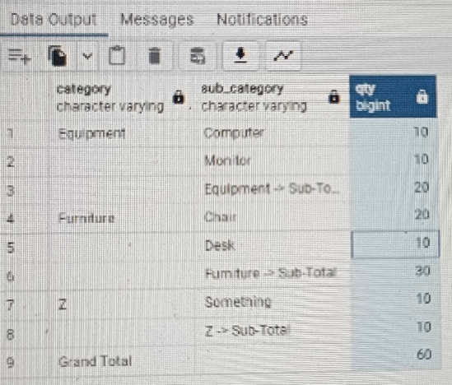

**What will happen in this case and how to fix it**

create table t1 (x int) partition by range(x)

insert into t1 values (1)

create table t1_part1 partition of t1 for values from (1) to (100);

create table t1_part2 partition of t1 for values from (50) to (100);

**What will happen in these cases**

create table t2 (x int, y char(500)) partition by hash(x);

create table t2_h1 partition of t2 for values with (modulus 3, remainder 0);

create table t2_h2 partition of t2 for values with (modulus 4, remainder 0);

create table t3 (x varchar(10), y char(500)) partition by hash(x);

create table t3_h1 partition of t3 for values with (modulus 3, remainder 0);

create table t3_h2 partition of t3 for values with (modulus 3, remainder 1);

Can you create indexes on specific partitions?

Can you create FKs on specific partitions?

What will happen when you create a default partition and insert data that goes into the date partition, and then have a partition that has the default values included?

Can we detach a partition from one table and attach it to another table with the same structure

Can DDLs be included in transactions?

Simulate Blocking using transactions

PROBLEM 1

explain select * from t1 where x = 50

union

select * from t1 where x = 100

Question: How many indexes are used in the query

Why is this step happening

" Sort Key: t1.x, t1.y, t1.a, t1.b, t1.c, t1.d, t1.e, t1.f, t1.g, t1.h, t1.i, t1.j, t1.k, t1.l"

PROBLEM 2

create table t4 (x int, y int) not null

create or replace view v_t4 as

select * from t4

select * from v_t4

alter table t4 add column z int

select * from v_t4

What happens and why

PROBLEM 3

insert into v_t4(x) values (3) --what will happen

PROBLEM 4

drop table t4 -- what will happen

PROBLEM 5

LOCAL CHECK

CACADED CHECK OPTION

What is the requirement to refresh a MV concurrently

How can you generate multiple rows using a simple query

**Q&A to be done**

https://tutorialslink.com/mcq-quiz/postgresql-mcq-quiz-multiple-choice-questions-and-answers

https://nhlink.net/business/100-top-postgresql-multiple-choice-questions-and-answers

https://letsfindcourse.com/database-mcq/postgresql-mcq-questions-and-answers

https://www.dailyrecruitment.in/postgresql-mcq-quiz-questions-and-answers/

https://www.onlineinterviewquestions.com/postgresql-mcq/

https://www.freshersnow.com/postgresql-mcqs-and-answers-with-explanation/